**Shruti Deshmukh**

**1.Create a new directory called linux-assignment in your home directory-**

***"mkdir***

**2.Navigate into the linux-assignment directory-**

***"cd***

**3.Create a new file called instructions.txt-**

***"touch instructions-txt"***

**4.Write "Hello, World!" into instructions.txt using a command-line text editor like nano, vi, or emacs-**

*"nano instructions.txt"*

**5.Display the contents of instructions.txt using a command-**

***"cat instructions.txt"***

**6.Rename instructions.txt to greetings.txt--**

***"mv instructions.txt greetings.txt"***

**7.Copy greetings.txt to a new file called salutations.txt-**

***"cp greetings.txt salutations.txt"***

**8.Delete greetings.txt-**

***"rm greetings.txt"***

**9.Create a new directory called archive-**

***"mkdir archive"***

**10.Move salutations.txt to the archive directory-**

***"mv salutations.txt archive/"***

**11.Display the current working directory to confirm that salutations.txt is now in the archive directory-**

***"pwd"***

**12.Navigate back to the linux-assignment directory and create three new empty files named file1.txt, file2.txt, and file3.txt-**

***"cd ~/linux-assignment"***

**13.Display the list of files in the linux-assignment directory to confirm the creation of the new files-**

***"touch file1.txt file2.txt file3.txt"***

**14.Create a new text file in your home directory named linux-assignment-commands.txt**

***"ls"***

**SNAPSHOTS OF LINUX ASSIGNMENT FILE AND COMMANDS EXECUTED ON TERMINAL**

**1**.SNAPSHOT OF LINUX COMMANDS EXECUTED ON TERMINAL-

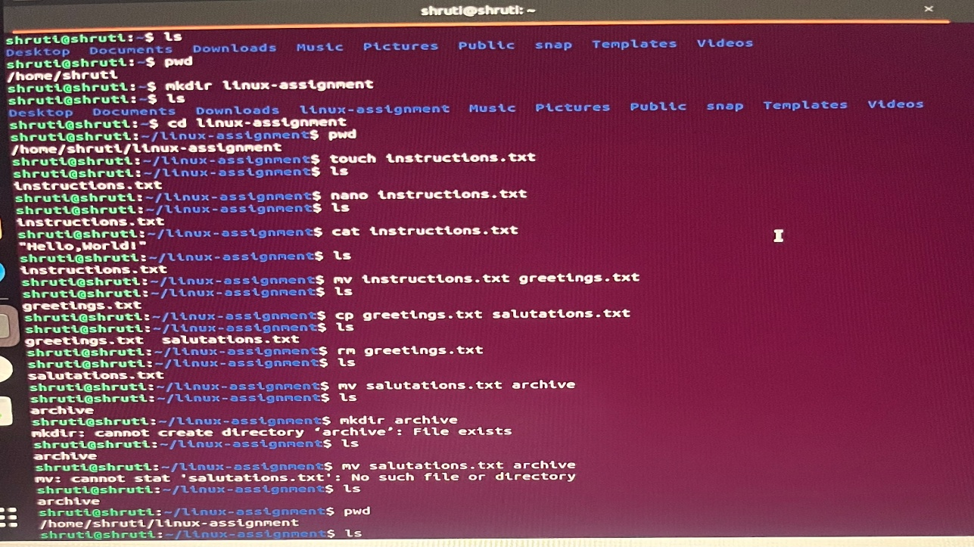

2. SNAPSHOTS OF LINUX ASSIGNMENT FILE

